Sports Gala 2k21

venue: Junaid Jamshed Stadium

2 & 3 December

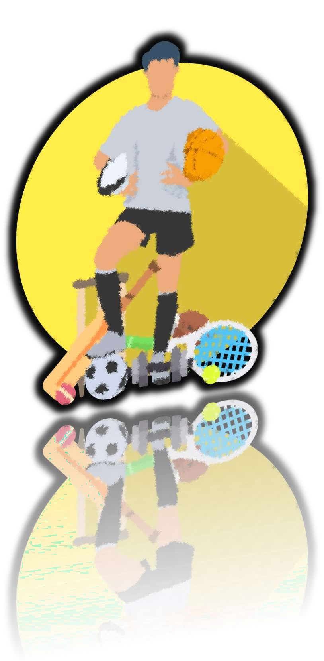Get ready for the

adrenaline rush